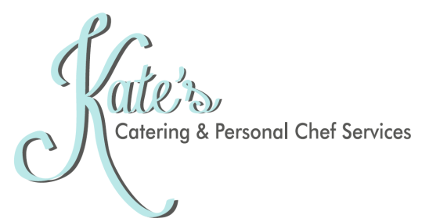

Corporate Meeting Refreshment Pricing
all pricing below is based on cost per person
delivery, serviceware, and labor may be an additional charge

Breakfast Snacks
House Made Quinoa Granola Bars: $2
Individual Fruit Cups: $2
Granola and Yogurt Parfaits: $2
Individual Seasonal Overnight Oats: $2
Assorted Scones, Muffins, and Quickbreads Tray: $5
Seasonal Fruit Presentation: $3
House Made Baked Donuts (choice of classic, chocolate dipped, and cinnamon sugar): $3
Bacon, Egg, and Cheddar Homestyle Biscuit Sandwich: $4
Sausage, Egg, and Cheddar Homestyle Biscuit Sandwich: $4
Egg and Cheddar Homestyle Biscuit Sandwich: $3

Savory Snacks
Individual Seasonal Crudite Cups with Choice of Dip: $2
House Flavored Gourmet Popcorn: $2
Bourbon Pimento Cheese Dip with Pretzel Crostini: $2
Spinach Artichoke Dip with Pita Chips: $2
Seasonal Hummus with Crudite and Pita Chips: $2
House Made Cheddar Cheese Pecan Crackers: $3
Gourmet Fruit, Cheese, and Nut Display with Crackers and Chutney: $4
House Made Candied Nut and Dried Fruit Medley: $3
Charcuterie Platter with Assorted Meats and Cheeses, Crackers, Mustard, and Olives: $5

Sweet Snacks
Assorted Cookies and Brownies Tray: $2
Pastry Cream and Fresh Berries Shooter: $3
Triple Chocolate Brownie Petit Fours: $3
Miniature Cheesecakes – Assorted Flavors: $3

Drinks and Libations
Assorted Coke, Diet Coke, Sprite, and Bottled Water: $2
Coffee Bar (includes coffee, creamers, and all the fixings): $6
- Add Hot Tea Service for just $1 more!
Beer and Wine Bar (including choice of wine, local, craft, and domestic beers): starting at $16
- Bartender for an additional charge

